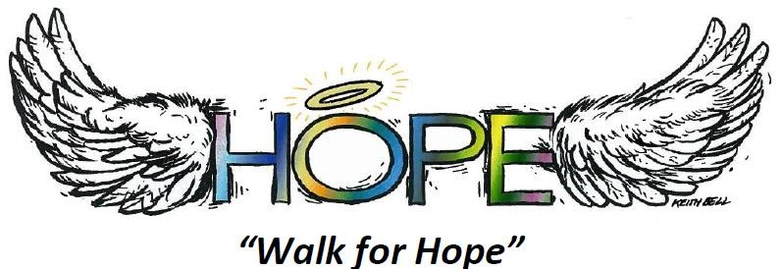
CHAVES COUNTY CANCER FUND
Gateway Christian School – Football Field
Saturday, October 18th, 2025 5:00 p.m. – 9:00 p.m.
SPONSORSHIP AGREEMENT
I, _______________________, of ___________________________, do hereby agree to sponsor
____ Signature Sponsor $7,500 (Logo needed)
____ 5-Star Sponsorship $5,000 (Logo needed)
____ 4-Star Sponsorship $2,500 (Logo Needed)
____ 3-Star Sponsorship $1,000
____ 2-Star Sponsorship $500
____ 1-Star Sponsorship $250
____ Other Donation
In exchange, my business will receive benefits on the sponsorship form. I understand that payment is required prior to printing any materials with sponsors’ name. Please make checks payable to “Walk for Hope”.
Authorized Signature_______________________________________Date_________________________
Company name to be used in promotions_______________________________Is a logo needed? ______
Address_______________________________________________________________________________
City________________________________ State_____________ Zip _____________________________
Phone_____________________ Email ______________________________________________________
For sponsorship questions, or to deliver your sponsorship check, contact the Walk for Hope committee at WalkforhopeRoswell@gmail.com

