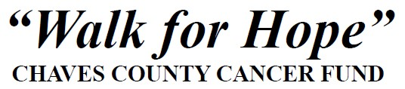
Gateway Christian School – Football Field
October 18th, 2025
5:00 p.m. – 9:00 p.m.
Sponsorship Opportunities

SIGNATURE SPONSOR $7,500 - Same as 5-Star Sponsorship, plus:
- Prime location at event
- Opportunity to speak at opening ceremony
- Receive up to 60 registrations and shirts

5-STAR SPONSORSHIP $5,000 - Name and logo prominently placed on event t-shirts
- Opportunity to display four (4) banners at event (sponsor provides)
- Name placed on all print media as presenting sponsor
- Receive up to 40 registrations and shirts
4-STAR SPONSORSHIP $2,500 - Name and logo prominently placed
on event t-shirts
- Opportunity to display three (3) banners at event (sponsor provides)
- Name placed on all print media as presenting sponsor
- Receive up to 20 registrations and shirts

3-STAR SPONSORSHIP $1,000 - Name on back of event t-shirts
- Opportunity to display two (2) banners at event (sponsor provides)
- Named as a sponsor in the event program and at the event

2-STAR SPONSORSHIP $500 - Named as a sponsor in the event program and at
the event

1-STAR SPONSORSHIP $250 - Named as a sponsor in the event program

For sponsorship questions, or to deliver your sponsorship check, contact the Walk for Hope committee at WalkforhopeRoswell@gmail.com

